**Experiment 1**

**Title:** Jenkins Installation + Configuration + Plugin Management

**Aim:** Install Jenkins on Windows operating system and Install required plugins from Plugin Management.

**Installation of Jenkins**

**Pre-requisites:**

1. Java JDK 1.8 or above installed and configured environment as shown below:  
     
   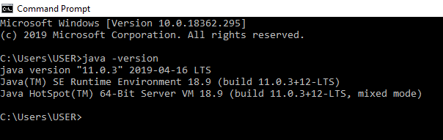
2. Maven 3.3.9 or above version installed and configured.

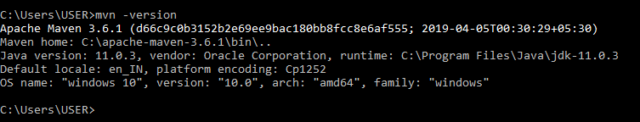

**Jenkins Installation steps**

1. Download Jenkins.war file from following link by selecting **Generic Java package(.war)**.  
   <https://jenkins.io/download/>

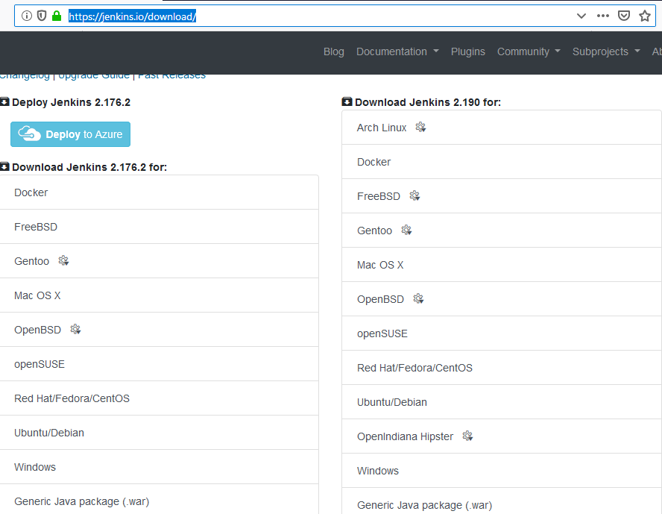

1. Open Command line in Windows and write the following command

**$ java –jar jenkins.war**

1. Open web browser and write following in the address bar:

**localhost:8080**

Wait till Jenkins loads up for the first time.

1. In the browser, Jenkins will ask for a 32-bit encryption key for authentication. It can be accessed from the command line used in step 2 or by manually going in **C://Users/{Username}/.jenkins/secrets/master.key** file.
2. Jenkins loads up for the first time on local machine.

**Jenkins Configuration**

When Jenkins loads for the first time, before the Signup page, it asks you to install some plugins required to run Jenkins and perform operations in it.

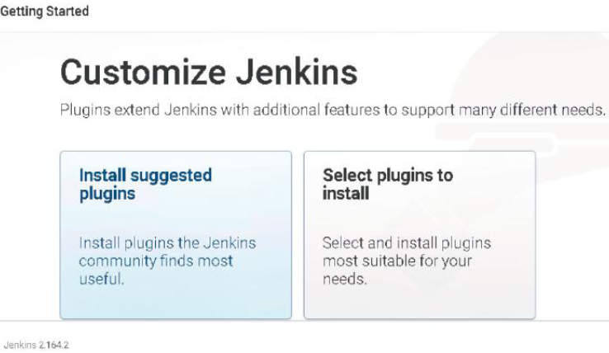

There are two options:

1. **Install Suggested tools** => Jenkins automatically downloads and installs bare minimum plugins required.
2. **Select plugins to install** => Select and download the plugins you need for your work.

**Signup:**

* Create Username and Password and login to Jenkins Portal. Additional users can be created later.
* Create new admin password if you want to override the default encryption key stored in .jenkins/secret/master.key file
* Click on “Start using Jenkins” button.

**Plugin Management**

1. On Jenkins Dashboard, click on **Manage Jenkins**.

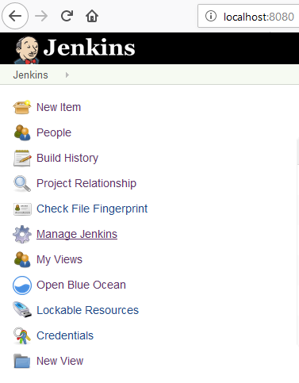

1. In Manage Jenkins, click on **Manage Plugins**

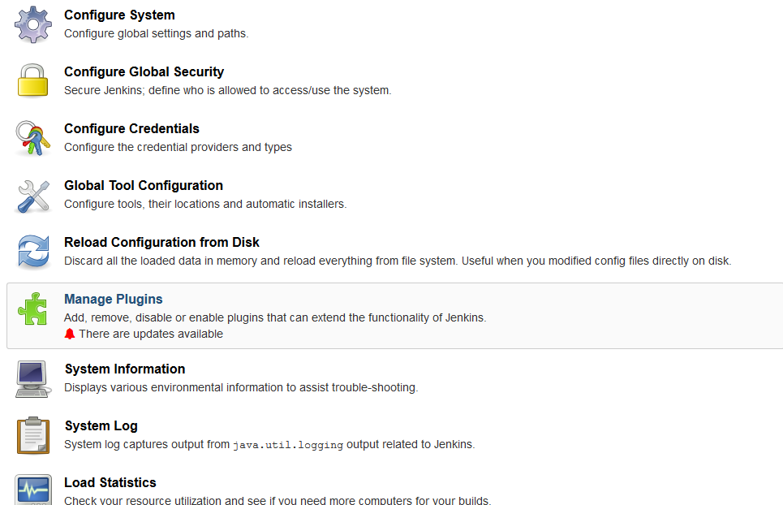

1. Go to **Available** Tab and select the required plugin.

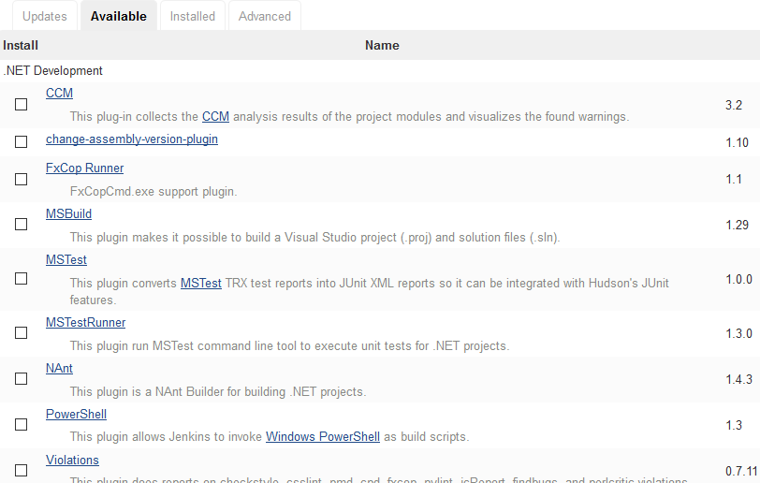

1. Click on **install without restart.**

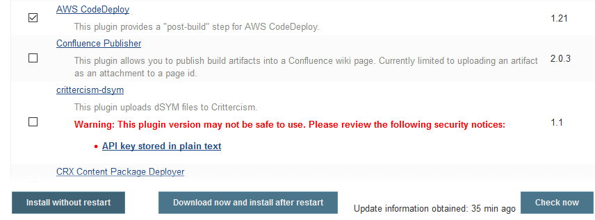

1. After successful installation of plugin, restart Jenkins to synchronize workspace with new plugin.

**Creation of first Jenkins Job**

1. Create “New Item” from Jenkins Dashboard given at left hand side of Jenkins Administrator page.

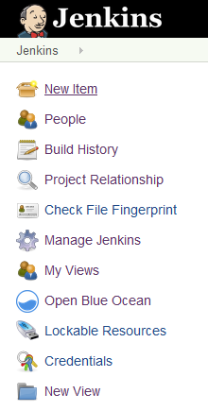

1. Type “Name” of the Item and select “Item type”.  
   Click on OK.

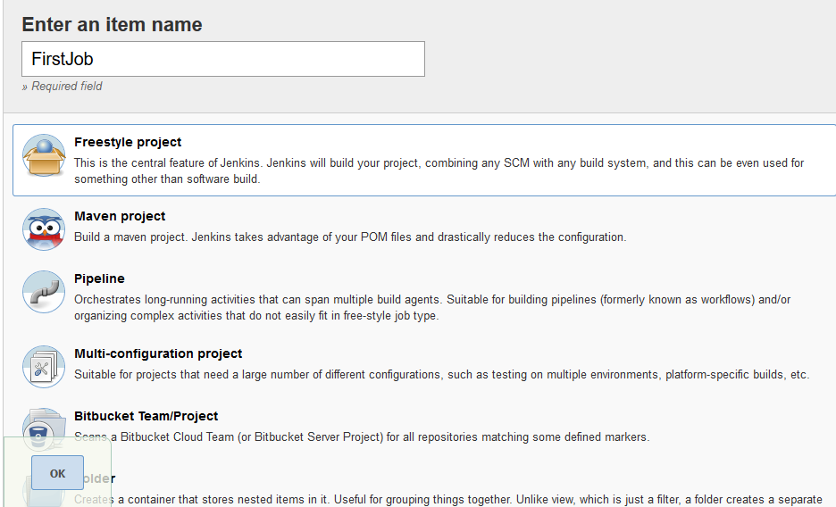

1. In the **Configuration** page, go to **Build** tab and select Windows Environment command.  
   Specify windows command:  
   Example: **java –version**

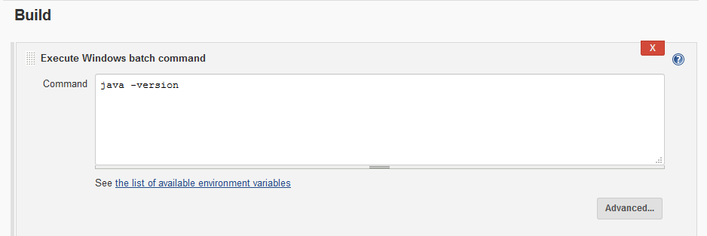

Click on **Apply** and then click on **Save.**

1. Go to Jenkins Dashboard.  
   Right click on the Job name and click on **Build now**

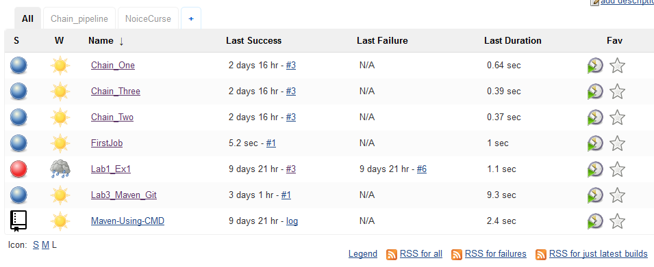

1. Right Click on build version and click on **Console Output.**